**STUDENT FEE MANAGEMENT REPORT**

**Project Overview:-**

The app is made in python language using tkinter and mysql connector.

The project is divided into two main users i.e. student, admin.

Student: Can login into the app and can check his/her details

Change password

View/search his/her fee details

Admin: Can login using admin login panel

Perform CRUD operations on user and search user on various fields as well

Can add or view fee details

**Project Screenshots:-**

**Login Panel (User)**

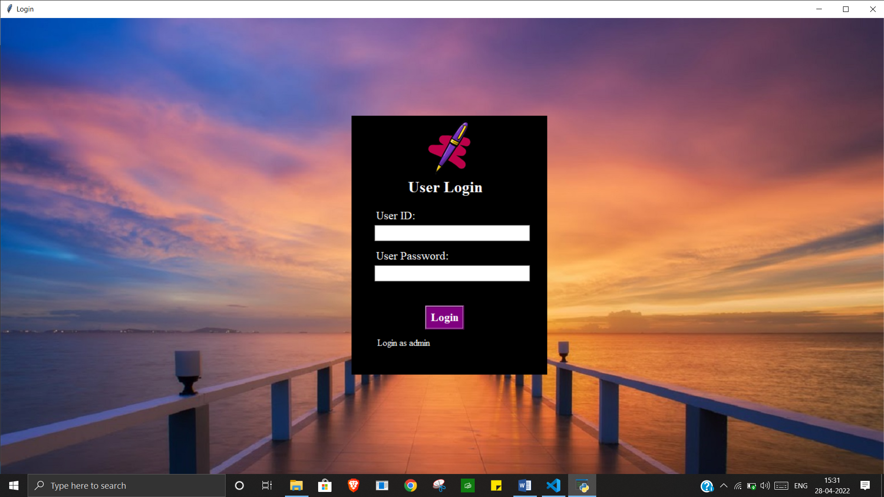

**Login Panel (Admin)**

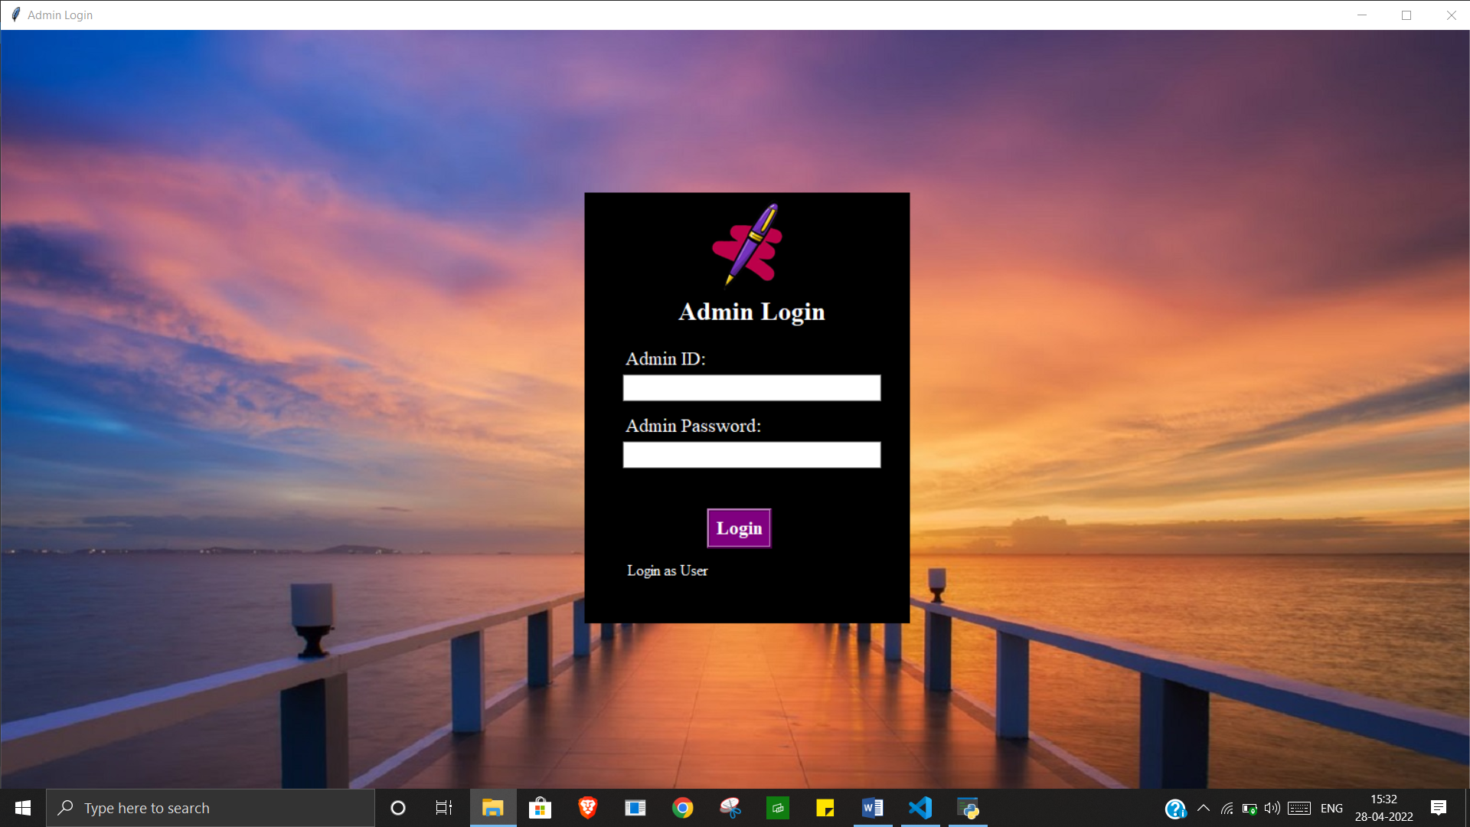

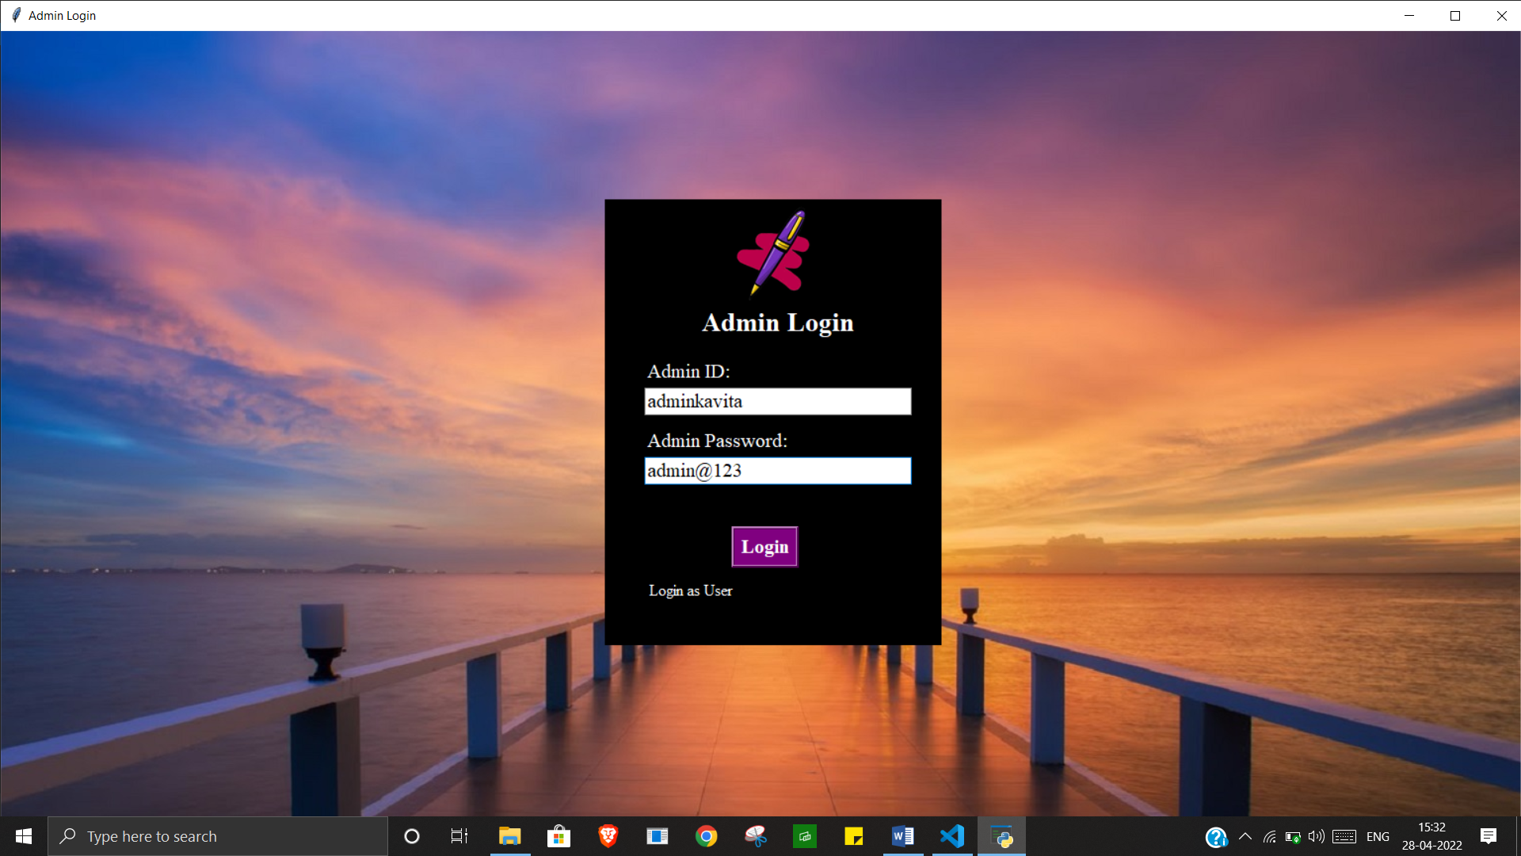

**Admin Panel**

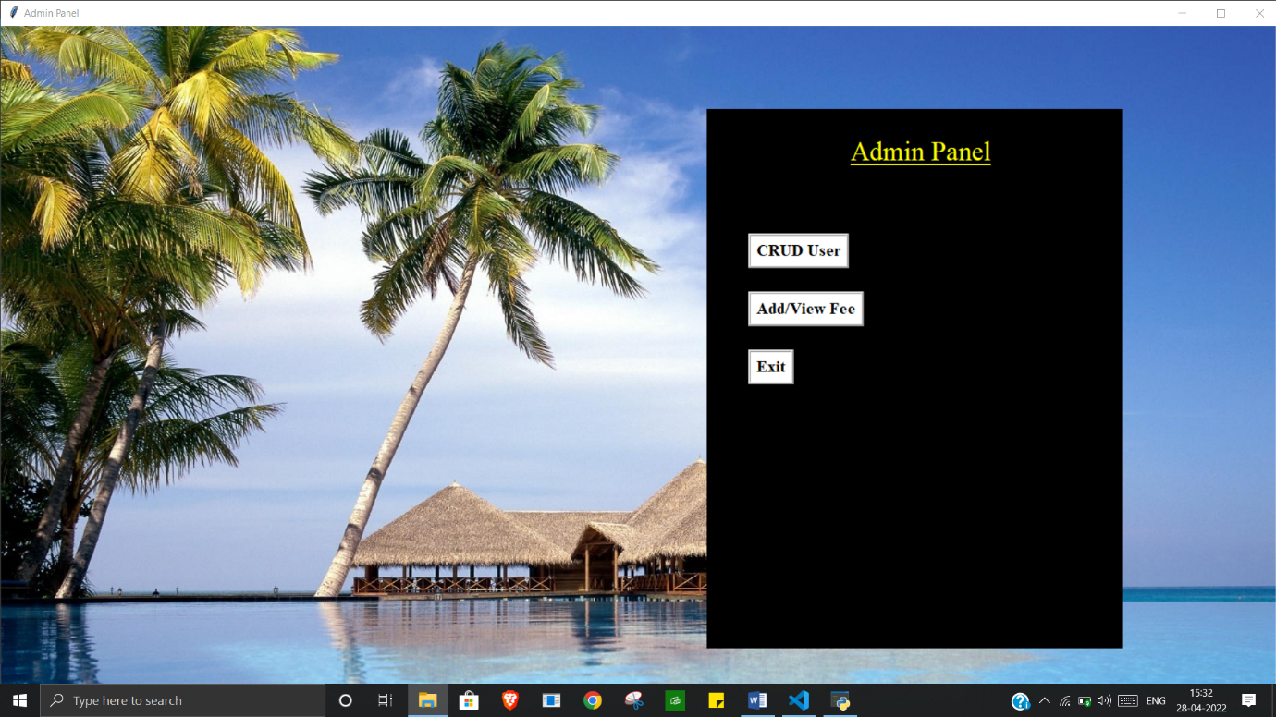

**Student management panel (CRUD + Search operation on user)**

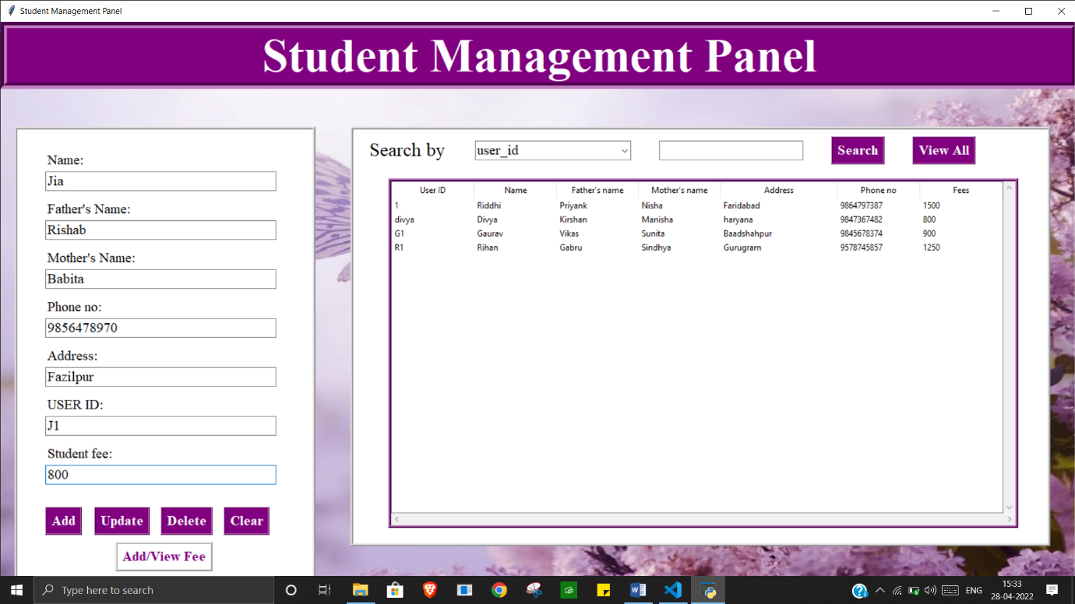

**Student data insertion**

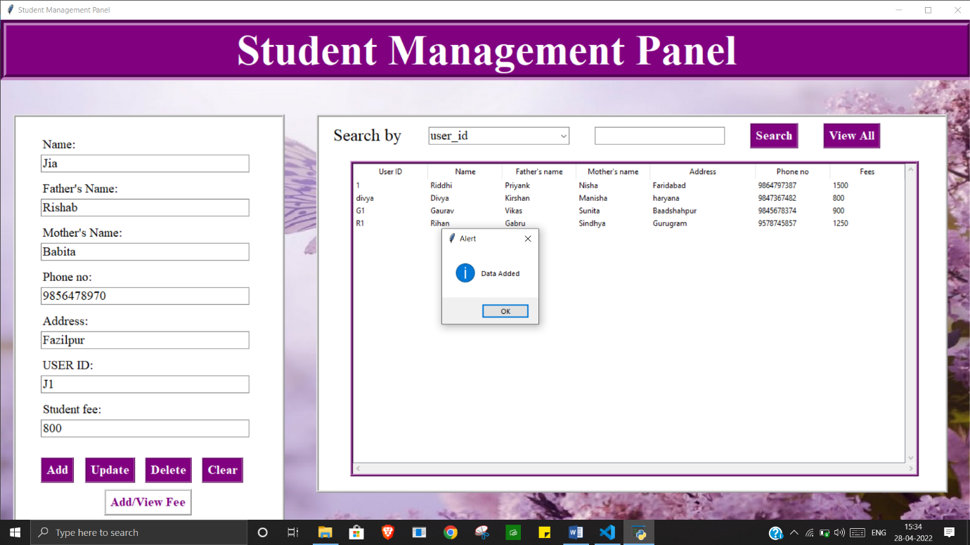

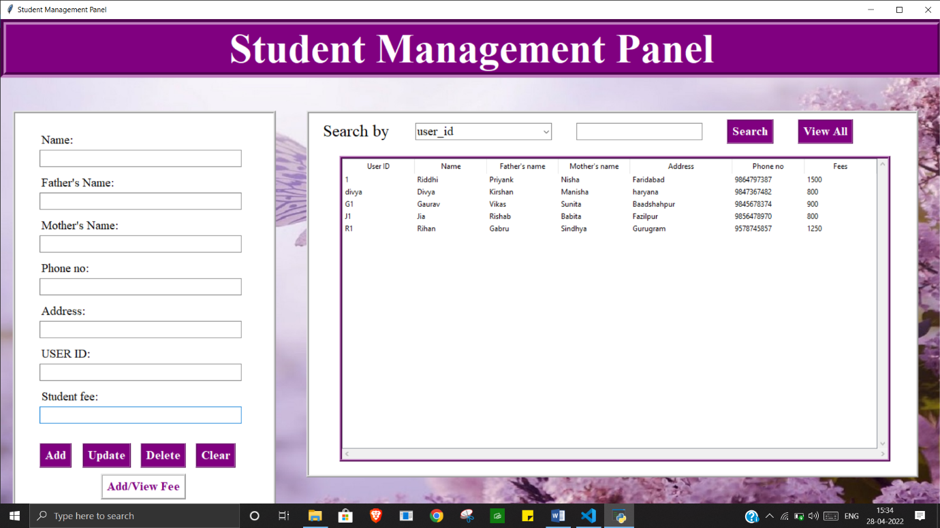

**Student data updation**

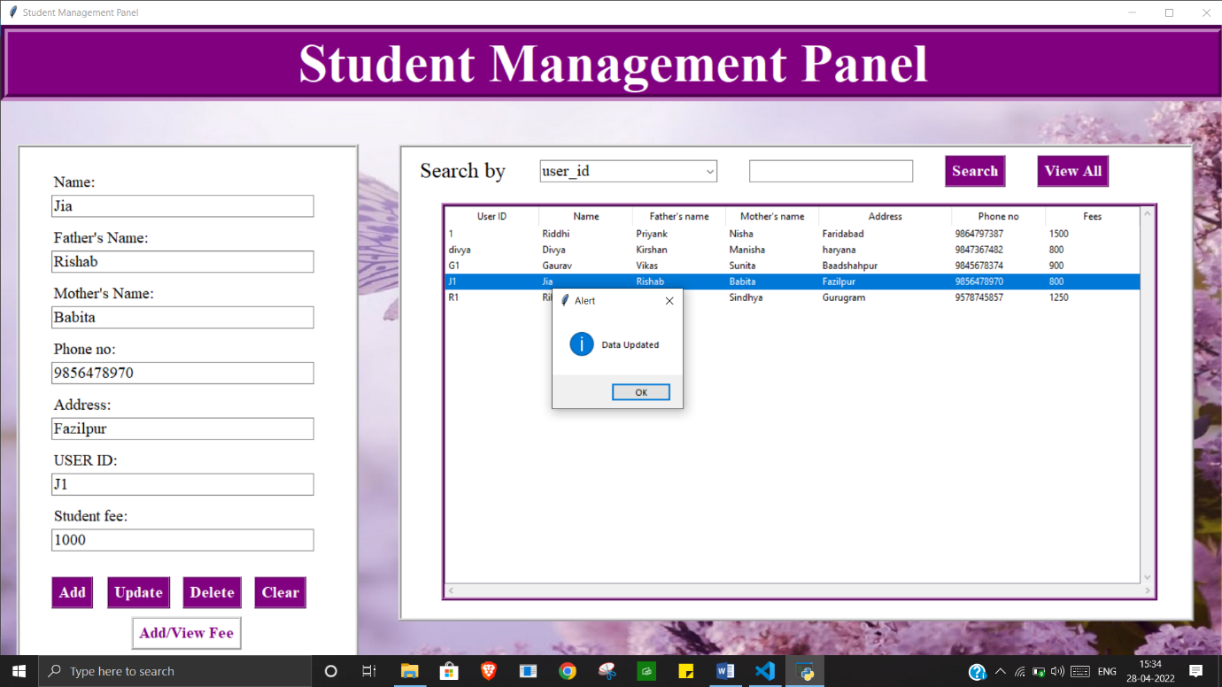

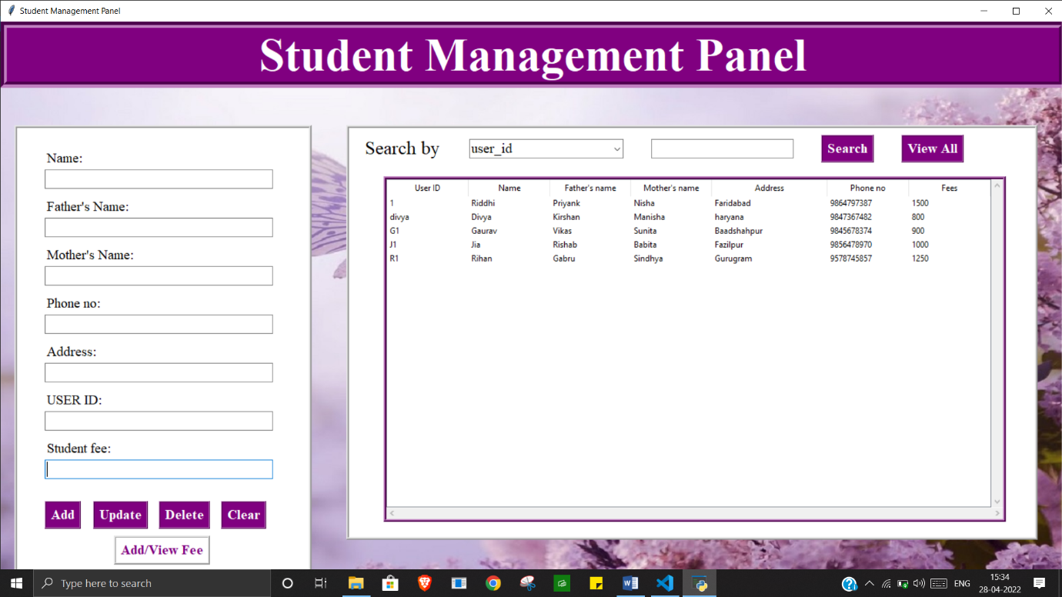

**Student data deletion**

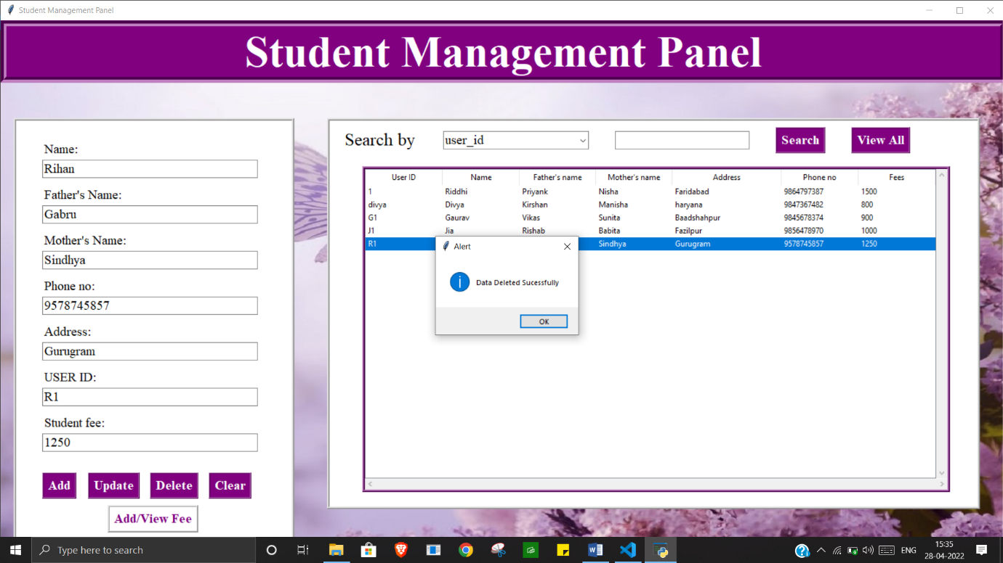

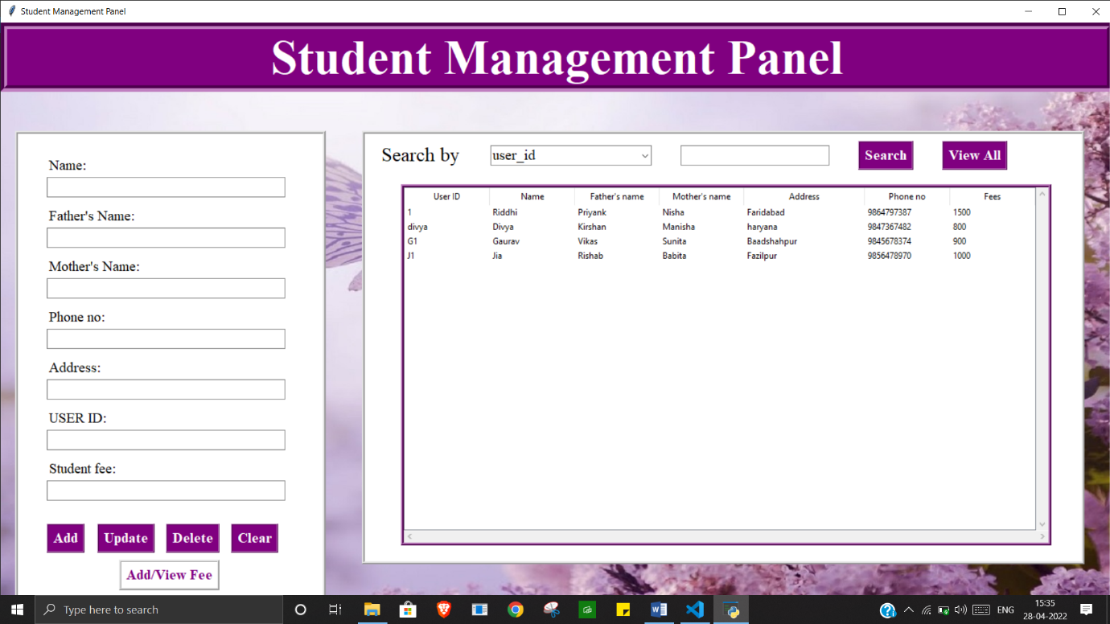

**Search operation**

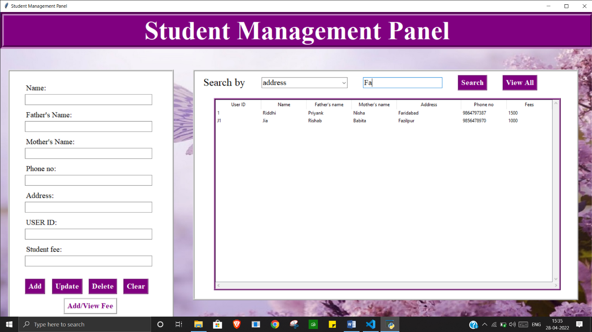

**Fee Management Panel**

**Payment insertion**

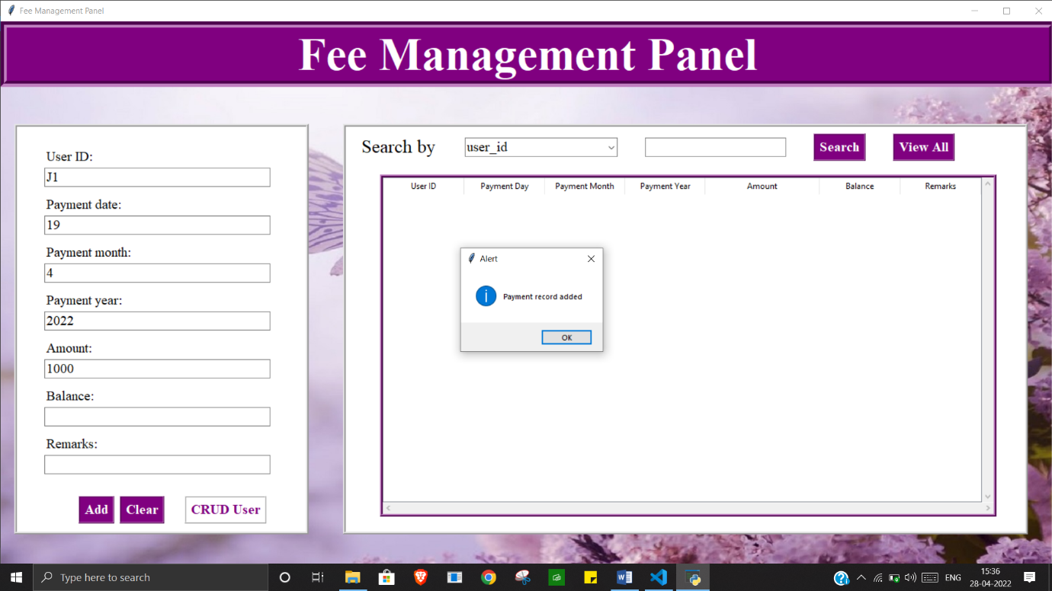

**View Payment**

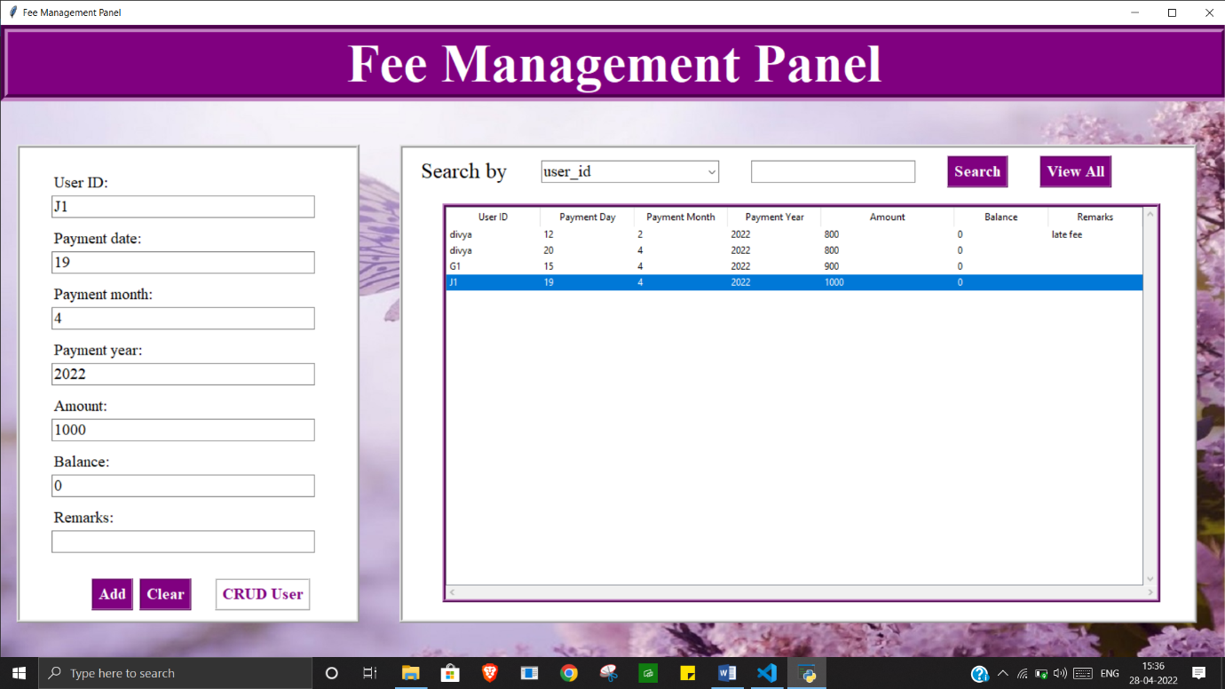

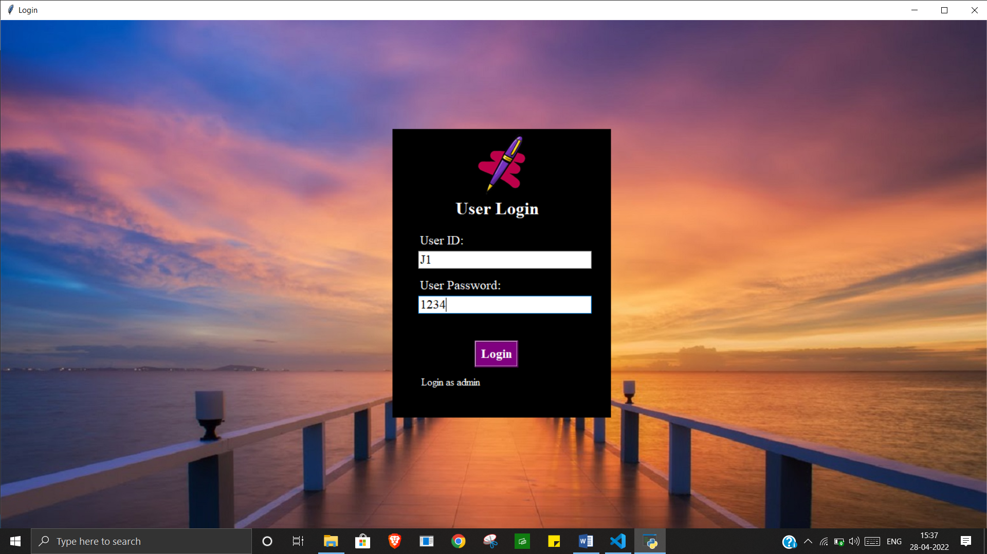

**Student Panel**

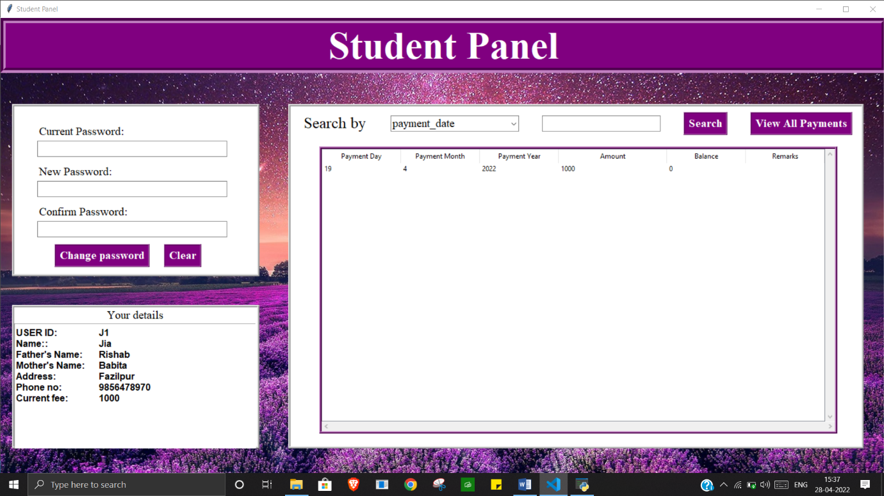

**Student password updation**

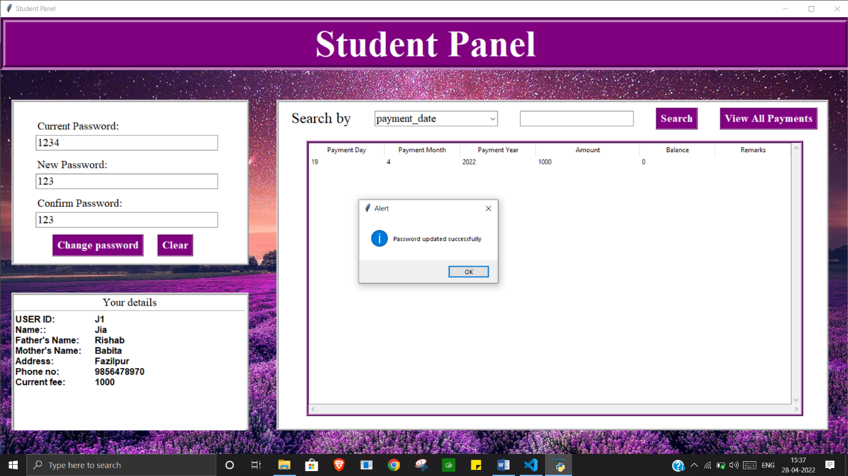

**Database Screenshots:-**

